Your Paper's Title Starts Here: Please Center (Time New Roman 14)
First Author¹, Second Author² and Last Author^{3,*}
¹Full address of first author, including country
²Full address of second author, including country
³Full address of third author, including country
*email: xxxx@yyyy.com
For the rest of the paper, please use Times Roman (Times New Roman) 12
Abstract. This template explains and demonstrates how to prepare your camera-ready paper for the ICAPMA-JMAG 2021 E-Proceedings. The best way is to read these instructions and follow the outline given in this text. Please make the page settings of your word processor to A4 format (21 x 29.7 cm or 8 x 11 inches); with the margins: bottom 1.5 cm (0.59 in) and top 2.5 cm (0.98 in), right/left margins must be 2 cm (0.78 in).
Keywords: List 3-5 keywords covering the main topics of your paper.
Introduction
All papers must be written in English, including the table and figure texts. Otherwise, we cannot publish your paper.
Please keep a second copy of your manuscript in your office. After receiving the paper, we assume that the corresponding authors grant us the copyright to use the paper for ICAPMA-JMAG 2021 E-Proceedings. Should authors use tables or figures from other publications, they must ask the corresponding publishers to grant them the rights to publish this material in their paper.
Use italic for emphasizing a word or phrase. Do not use boldface typing or capital letters except for section headings (cf. remarks on section headings, below).
Organization of the Text
Section Headings. The section headings are in boldface capital and lowercase letters. Second level headings are typed as part of the succeeding paragraph (like the subsection heading of this paragraph).
Page Numbers. Do not use page number in your paper:
Tables. Tables (refer with: Table 1, Table 2, ...) should be presented as part of the text, but in such a way as to avoid confusion with the text. A descriptive title should be placed above each table. Units in tables should be given in square brackets [meV]. If square brackets are not available, use curly {meV} or standard brackets (meV).

Table 1 A table with headings spanning two columns and containing notesª.
Nucleus | Thickness  (mg cm^{–2}) | Composition | Separation energies
Nucleus | Thickness  (mg cm^{–2}) | Composition | X, n (MeV) | Y, 2n (MeV)
¹⁸¹Ta | 19.3±0.1^{b} | Natural | 7.6 | 14.2
²⁰⁸Pb | 3.8±0.8^{c} | 99% enriched | 7.4 | 14.1
²⁰⁹Bi | 2.6±0.01^{c} | Natural | 7.5 | 14.4
ª Notes are referenced using alpha superscripts.
^{b} Self-supporting.
^{c} Deposited over Al backing.

Special Signs. for example , α γ μ Ω () ≥ ± ● Γ {110} should always be written with the fonts Times New Roman or Arial, including those in the figures and tables.
Macros. Do not use any macros for the figures and tables. (We will not be able to convert such papers into our system)
Language. All text, figures and tables must be in English.
Figures. Figures (refer with: Fig. 1, Fig. 2, ...) should also be presented as part of the text, leaving enough space so that the caption will not be confused with the text. The caption should be self-contained and placed below or beside the figure. Generally, only original drawings or photographic reproductions are acceptable. Only very good photocopies are acceptable. Utmost care must be taken to insert the figures in correct alignment with the text. Half-tone pictures should be in the form of glossy prints. If possible, please include your figures as graphic images in the electronic version. For best quality, the pictures should have a resolution of 300 dpi(dots per inch).
Color figures are welcome for the online version of the E-Proceedings. Generally, these figures will be reduced to black and white for the printed version (if available). The author should indicate on the checklist if he wishes to have them printed in full color and make the necessary additional payments in advance.

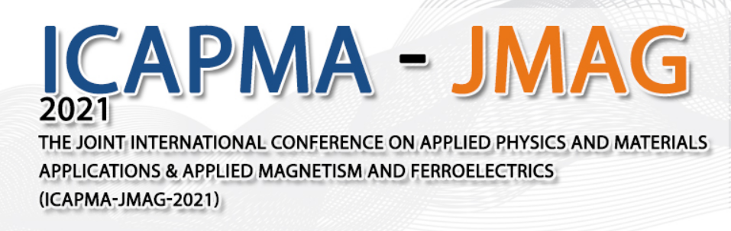

Figure 1. Figure with short caption (caption centred).

Equations. Equations (refer with: Eq. 1, Eq. 2, ...) should be indented 5 mm (0.2"). There should be one line of space above the equation and one line of space below it before the text continues. The equations have to be numbered sequentially, and the number put in parentheses at the right-hand edge of the text. Equations should be punctuated as if they were an ordinary part of the text. Punctuation appears after the equation but before the equation number. The use of Microsoft Equation is allowed.
c² = a² + b². (1)
Literature References
References are cited in the text just by square brackets [1]. (If square brackets are not available, slashes may be used instead, e.g. /2/.) Two or more references at a time may be put in one set of brackets [3,4]. The references are to be numbered in the order in which they are cited in the text and are to be listed at the end of the contribution under a heading References, see our example below.
Summary
If you follow this “guideline”, your paper will conform to the requirements of ICAPMA-JMAG 2021 E-Proceedings and facilitate a problem-free publication process.
References
[1] J. van der Geer, J.A.J. Hanraads, R.A. Lupton, The art of writing a scientific article, J. Sci. Commun. 163 (2000) 51-59.
Reference to a book:
[2] W. Strunk Jr., E.B. White, The Elements of Style, third ed., Macmillan, New York, 1979.
Reference to a chapter in an edited book:
[3] G.R. Mettam, L.B. Adams, How to prepare an electronic version of your article, in: B.S. Jones, R.Z. Smith (Eds.), Introduction to the Electronic Age, E-Publishing Inc., New York, 1999, pp.281-304.
[4] R.J. Ong, J.T. Dawley and P.G. Clem: submitted to Journal of Materials Research (2003)
[5] P.G. Clem, M. Rodriguez, J.A. Voigt and C.S. Ashley, U.S. Patent 6,231,666. (2001)
[6] Information on http://www.weld.labs.gov.cn

